Homework 5

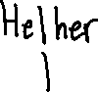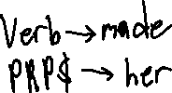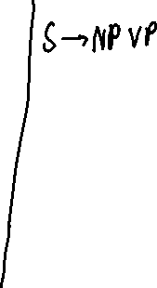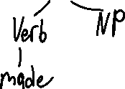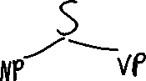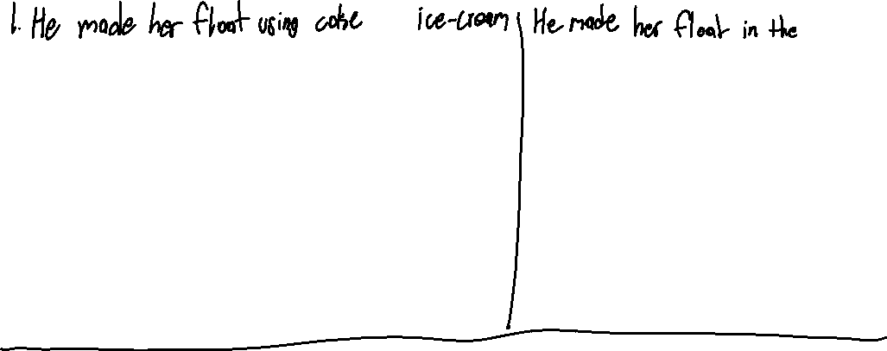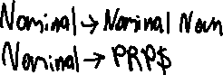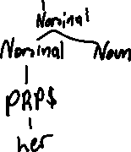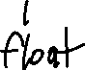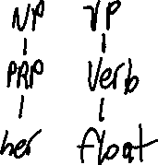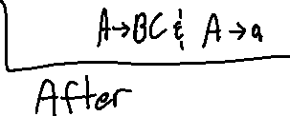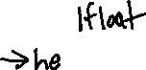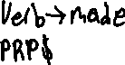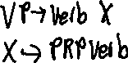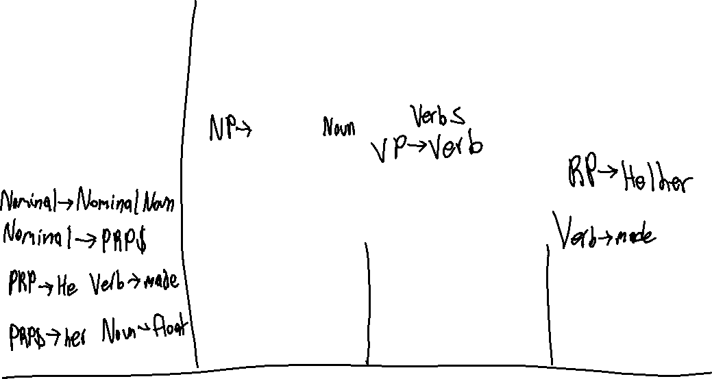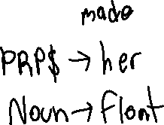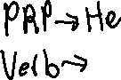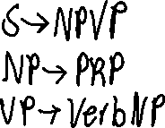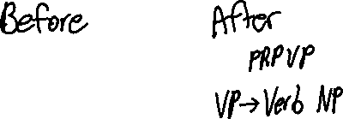

4.

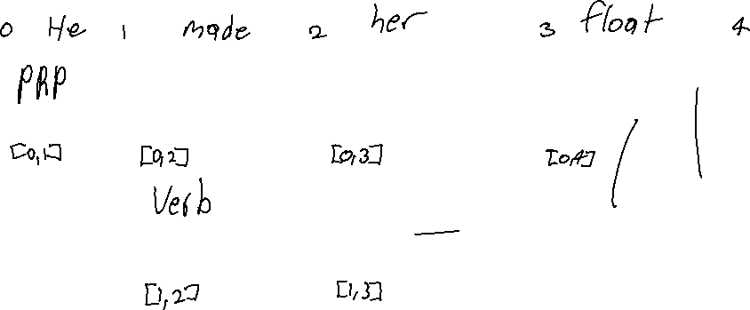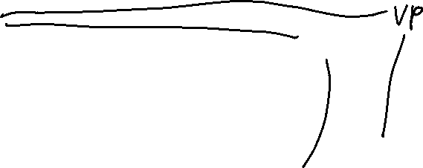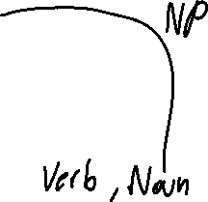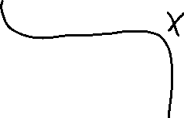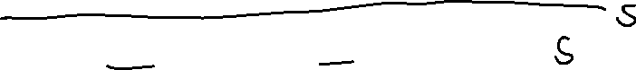

Chart [0]

S0 gamma -> .S [0, 0] [S0] dummy start state

S1 S -> .NP VP [0, 0] [S0] predictor

S2 S -> .PRP VP [0, 0] [S1] predictor

S3 NP -> .PRP$ Nominal [0, 0] [S2] predictor

Chart[1]

S4 PRP -> he . [0, 1] [S3] scanner

S5 S -> PRP .VP [0, 1] [S4] completer

S6 VP -> .Verb [1, 1] [S4] predictor

S7 VP -> .Verb NP [1, 1] [S4] predictor

Chart[2]

S8 Verb -> made . [1, 2] [S4] scanner

S9 VP -> Verb . [1, 2] [S8] completer

S10 VP -> Verb .NP [1, 2] [S8] completer

S11 S -> PRP VP . [0, 2] [S4, S9] completer

S12 NP -> .PRP$ Nominal [2, 2] [S9] predictor

Chart[3]

S13 PRP$ -> her . [2, 3] [S9] scanner

S14 NP -> PRP$ .Nominal [2, 3] [S13] completer

S15 Nominal -> .Noun [3, 3] [S13] predictor

S16 Nominal -> .Noun Nominal [3, 3] [S13] predictor

Chart[4]

S17 Noun -> float . [3, 4] [S13] scanner

S18 Nominal -> Noun . [3, 4] [S17] completer

S19 Nominal -> Noun .Nominal [3, 4] [S17] completer

S20 NP -> PRP$ Nominal . [2, 4] [S13, S18] completer

S21 Nominal -> .Noun [4, 4] [] predictor

S22 Nominal -> .Noun Nominal [4, 4] [S18] predictor

S23 VP -> Verb NP . [1, 4] [S8, S20] completer

S24 Nominal -> Noun Nominal . [3, 4] [S17, S21] completer

S25 S -> PRP VP . [0, 4] [S4, S23] completer